Online Exam Management System

User Manual

# **Table of Contents**

**Table of Contents 1**

**Running the Program after Setup 1**

Manual Exam Generation 6

1. Getting Started 6

4. During the Exam 7

7. After the Exam 7

Editing Exams 7

Logging in as a Schedule Manager 8

Logging in as a Student 9

Logging in as an Instructor 9

Personal Account Management 11

Loading a Class Roster 12

Editing a Student 16

## **Running the Program after Setup**

After getting all the program files open in Eclipse you’ll want to run the program.

1. You’ll need to right click on the top of the files tree, hover over **Run As**, then click Spring Boot Apps

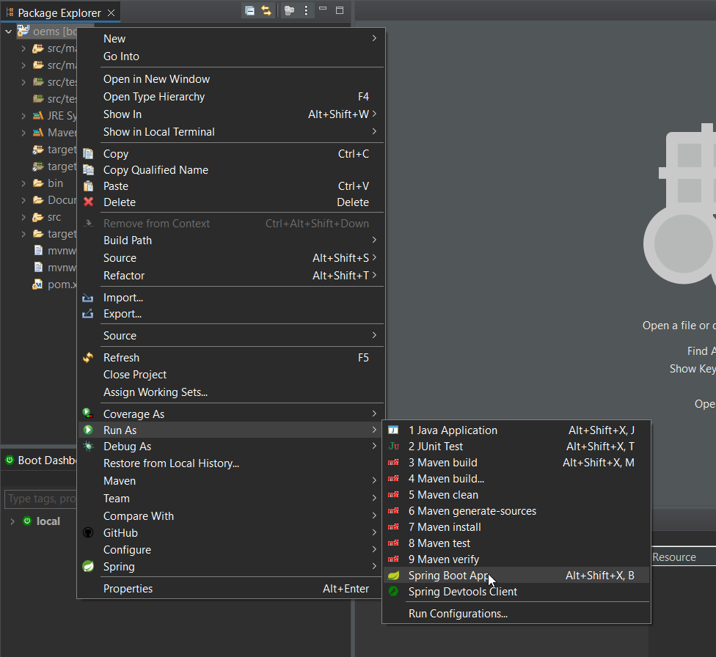

1. You will then need to navigate to your browser of choice and type *localhost:8080* into the url bar. The login page will be displayed.

*user: root, pass: software*

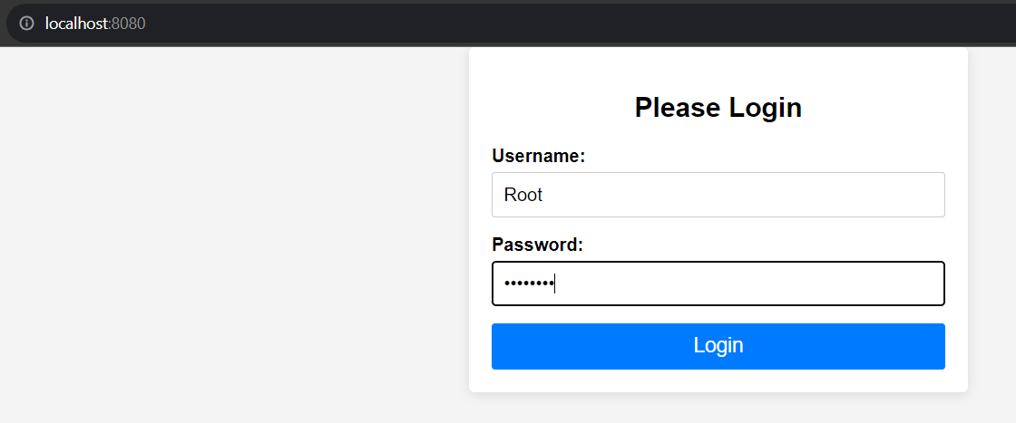

1. After Logging in you will be presented with the Main Screen for an Administrator.

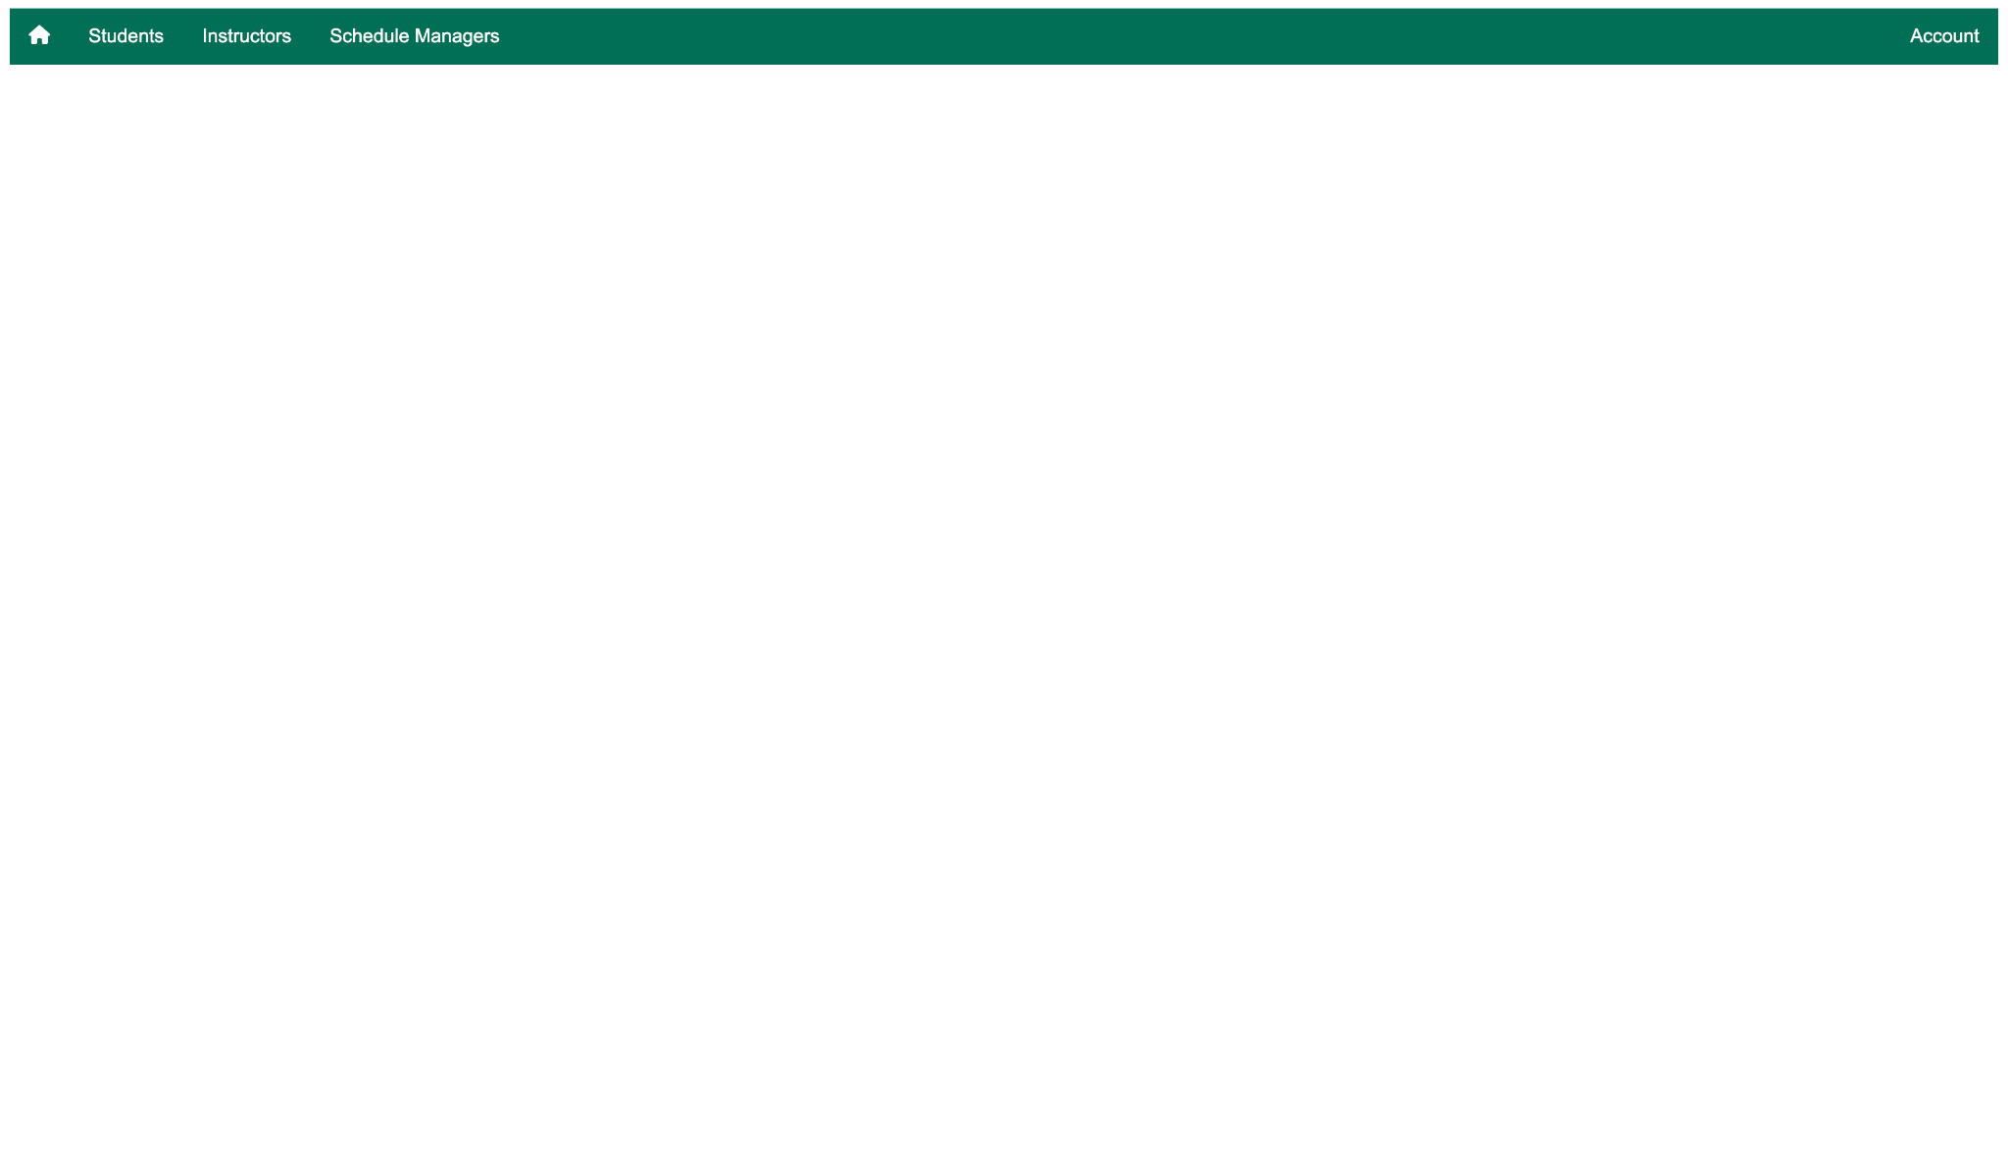

* This is the view of an administrator, the sole role of the administrator is interaction of the database, creating students, instructors and other administrators. They should not have the privilege of interacting with classes or associations.
  + Students
    - The administrator is able to see a list of all students, and is able to edit/delete them directly from the table as shown below:
      * EDIT: Administrator option to edit information of a student
      * DELETE: Administrator option to edit information of a student

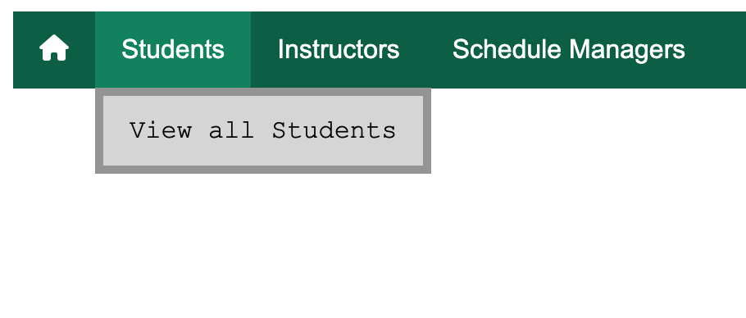

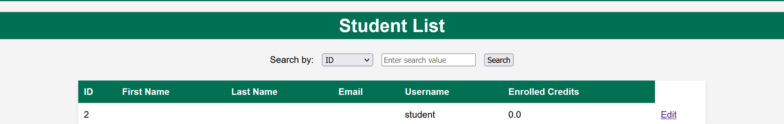

* + Instructors
    - The administrator is able to see a list of all instructors, and is able to edit/delete them directly from the table as shown below:
      * EDIT: Administrator option to edit information of an instructor
      * DELETE: Administrator option to edit information of an instructor

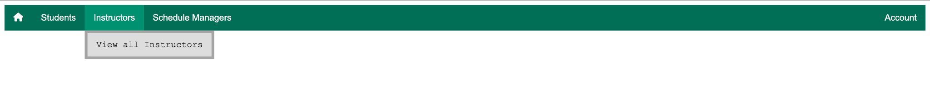

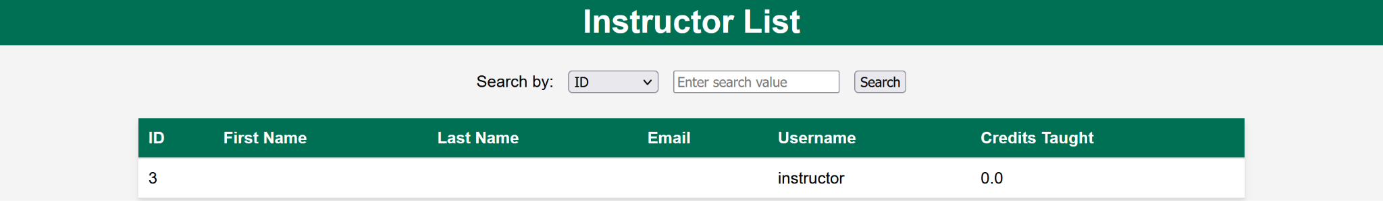

* + Schedule Managers
    - The administrator is able to see a list of all schedule managers, and is able to edit/delete them directly from the table as shown below:
      * EDIT: Administrator option to edit information of a schedule manager
      * DELETE: Administrator option to edit information of a schedule manager

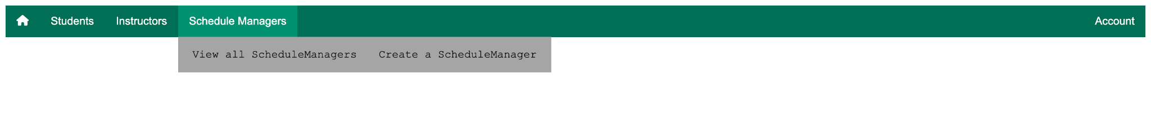

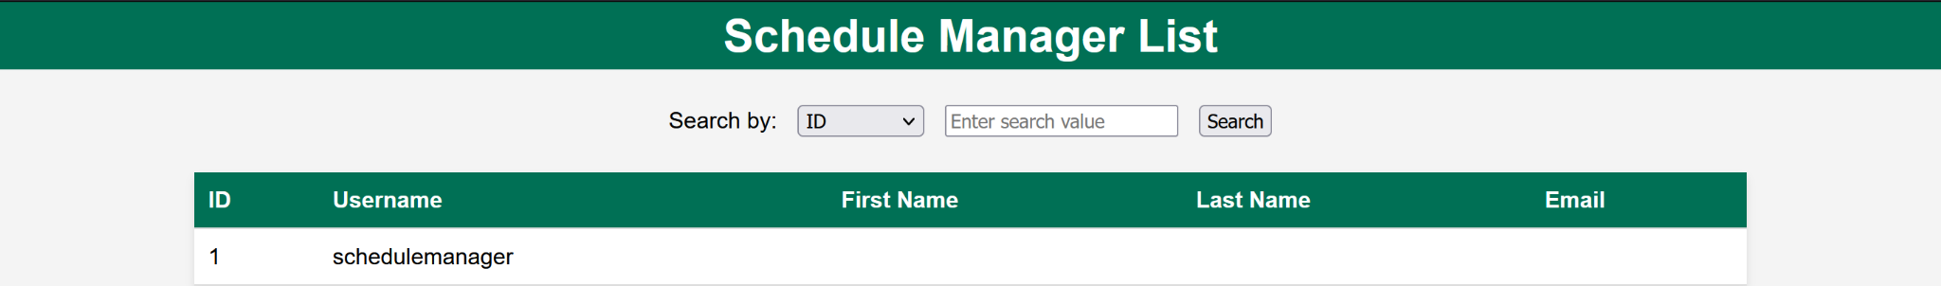

* + - The administrator has an option of creating a schedule manager, the role of a schedule manager is to handle the associations between students and courses, and the creation of students and instructors.

**A.I. Exam Generation**

1. At the navbar page, hover over **Exam Generation** and click on AI Generate Exam

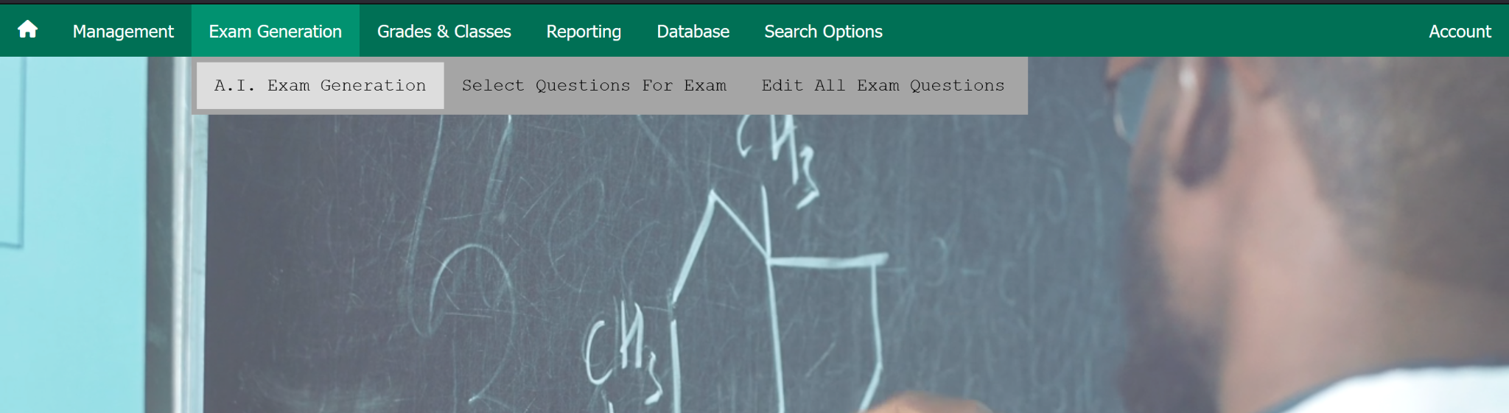

1. You will be met with the following prompt page

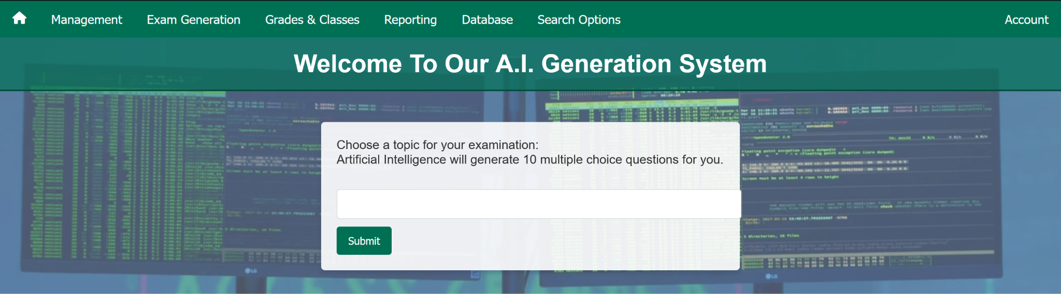

1. Within the prompt box, make sure to write an examination topic of your choice. It can be anything. Click **Submit**
2. You will be met with a confirmation page, click **Yes, proceed** and allow for about 5-10 seconds for the exam to generate itself.



1. Then you will be met with the A.I. generated exam
2. 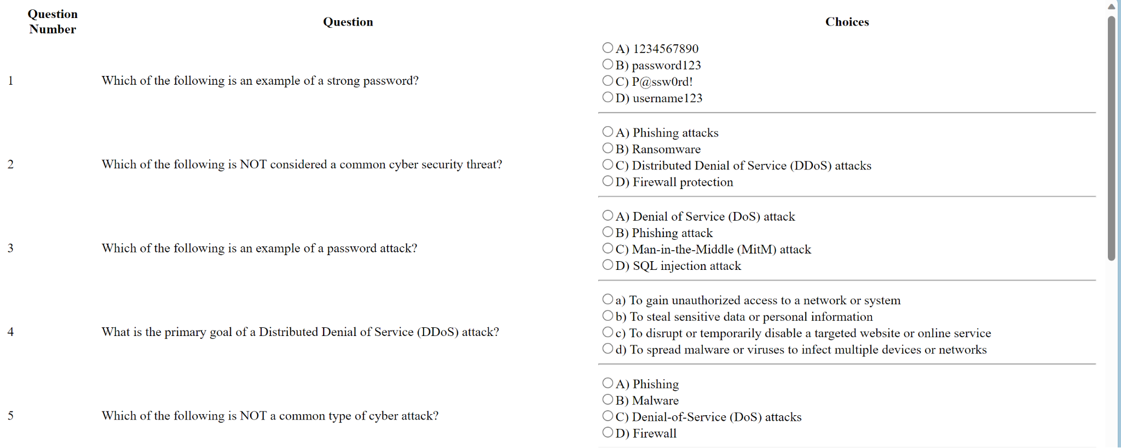
3. You will have an option to export the exam to an excel file or .txt at the bottom of the page
   1. 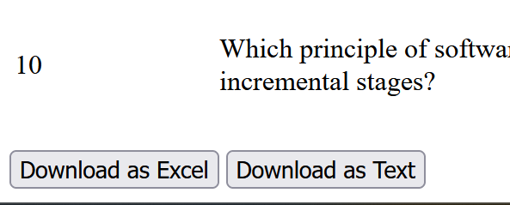

## **Manual Exam Generation**

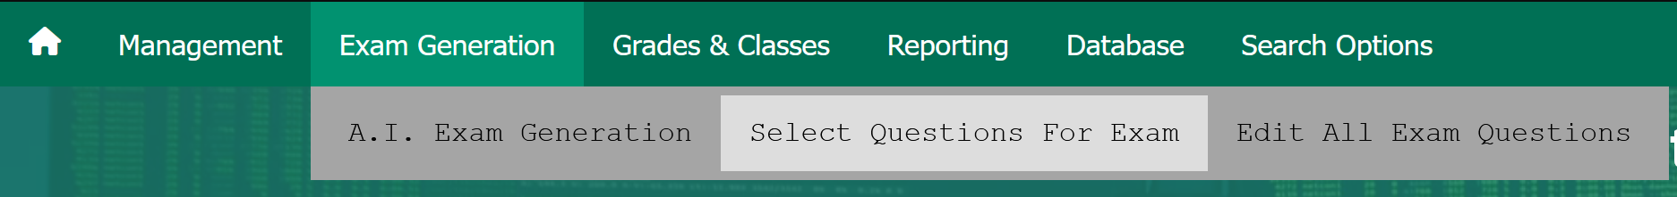

#### **Getting Started**

As seen above, click on ‘Select Questions for Exam’. Select Questions, and click ‘submit’.

1. **Accessing an Exam**

Upon clicking submit, you will be provided with a unique link, directing you to your exam. Click on this link, and you'll be taken to a webpage displaying your exam questions.

1. **Exam Duration**:

Be aware of the exam's time limit. The system ensures fairness by only allowing answers to be submitted within this official duration. The duration is set by the instructor.

#### **During the Exam**

Here's what you can expect when you're taking your exam:

1. **Answering Questions**:

For each question, you'll select your answer from the provided options.

1. **Submitting Your Exam**:

Once you've answered all questions, you'll click the 'Submit' button. This action finalizes your exam and sends your answers for evaluation.

#### **After the Exam**

After submitting your exam, here's what will happen:

1. **Score Calculation**:

The system automatically calculates your score based on the correct responses you provided.

1. **Viewing Your Results**:

After evaluation, you'll be able to see your total score, along with feedback on any incorrect answers.

## **Editing Exams**

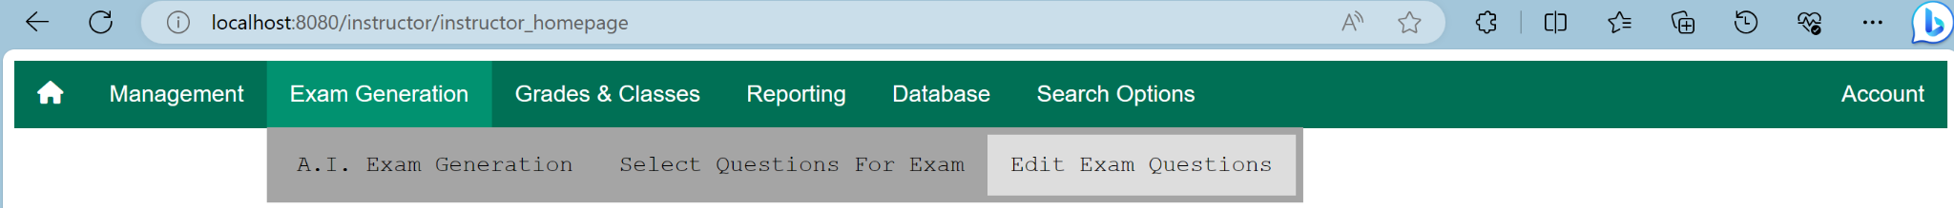

1. By clicking on the ‘Edit Exam Questions’ as seen above, an instructor can manipulate, edit, add or delete questions and their respective options as they please.

## **Logging in as a Schedule Manager**

The default login and password to view the schedule manager homepage are as follows:

Username: schedulemanager

Password: schedulemanager

1. You will be prompted with this page

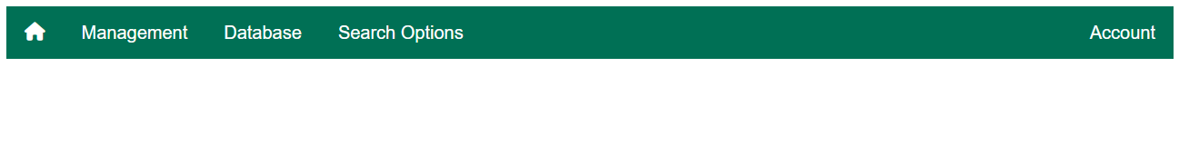

1. You have a navigation bar that has multiple options, the current options that are available are Management, Database, Search Options. The role of the schedule manager is to handle the associations between the students/instructors and their classes.
   1. Management
      1. View All Instructors - This option will display a page of all the instructors that are created in the database.
      2. View All Students - This option will display a page of all the students that are created in the database.
      3. Load a Class - this option will display a page that gives you the option to upload a roster of a class, we go into more detail in the section titled **Loading a Class Roster.**

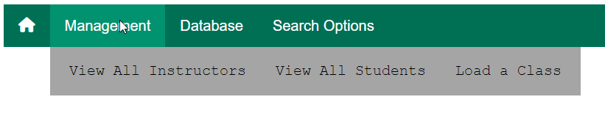

* 1. Database -
     1. Add Student - This option allows you to create a singular student account so the student may login to the system.
     2. Add Instructor - This option allows you to create a singular Instructor account so the student may login to the system.
     3. Add Courses - This option allows you to create a course, you are able to name it and give it an ID.
     4. Assign Students - This option allows you to assign a pre-existing student to a pre-existing course.
     5. Assign Instructor - This option allows you to assign a pre-existing instructor to a pre-existing course.

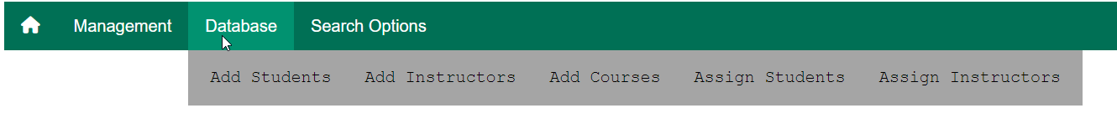

* 1. Search Options - ***Currently not functional***

## **Logging in as a Student**

The default login and password to view the Student Homepage are as follows:

Username: student

Password: student

1. When logging in as a student you will be prompted by this page

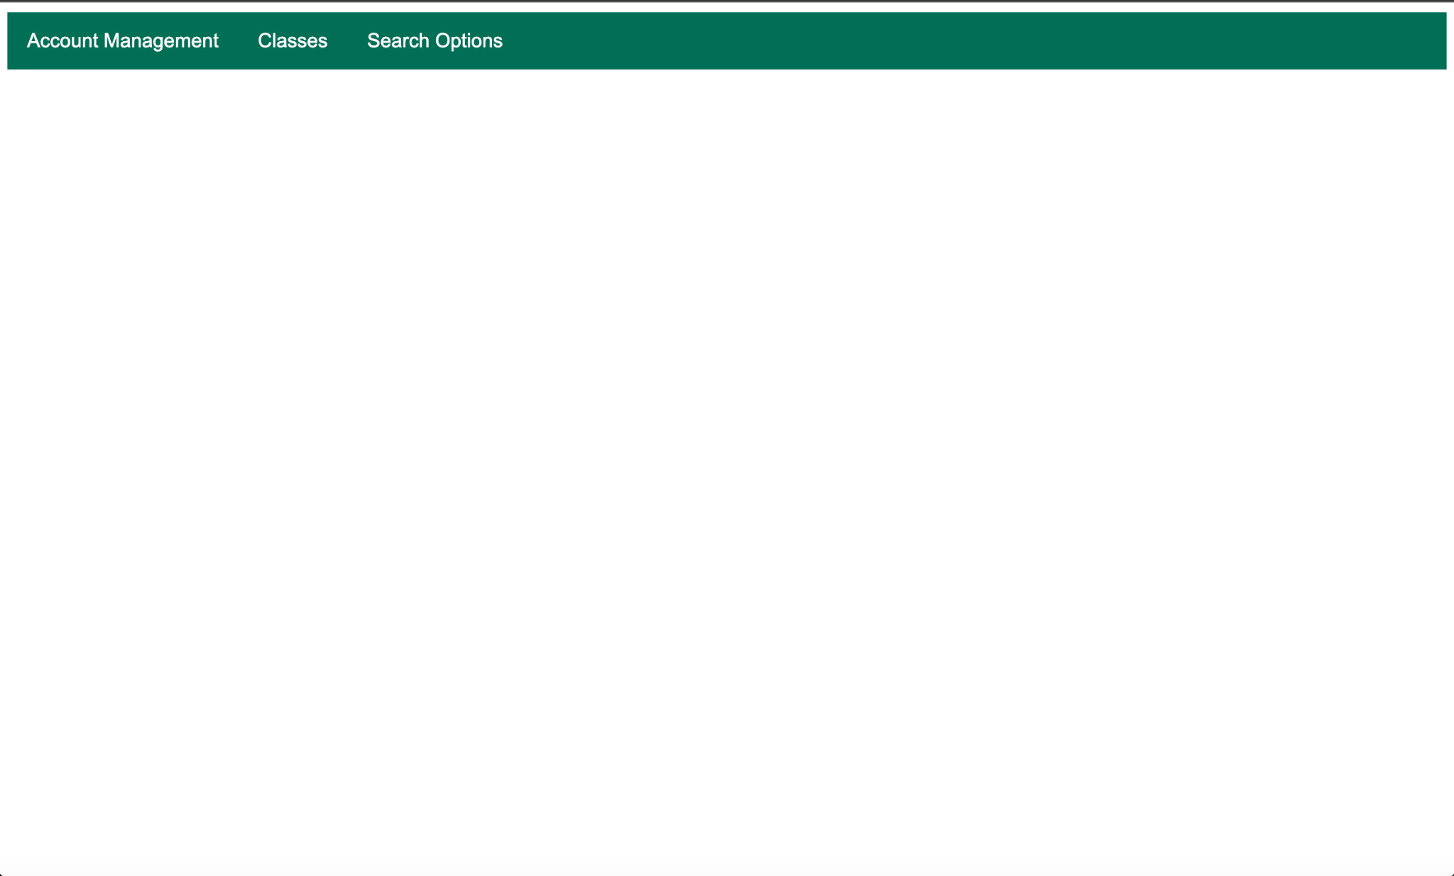

1. You have a navigation bar that has multiple options, the current options that are available are Account Management, Classes, Search Options. The role of the student is simply as it sounds, it is to complete assignments and objectives that the instructor assigns.
   1. Account management
      1. Change password - ***Currently not functional***
      2. Logout - Logout function for student
   2. Classes- ***Currently not functional***
      1. ***Class 1 - for student***
      2. ***Class 2 - for student***
   3. Search options
      1. Search - ***Currently not functional***

## 

## **Logging in as an Instructor**

The default login and password to view the Instructor Homepage are as follows:

Username: instructor

Password: instructor

1. When logged in as an instructor you will be prompted with this homepage

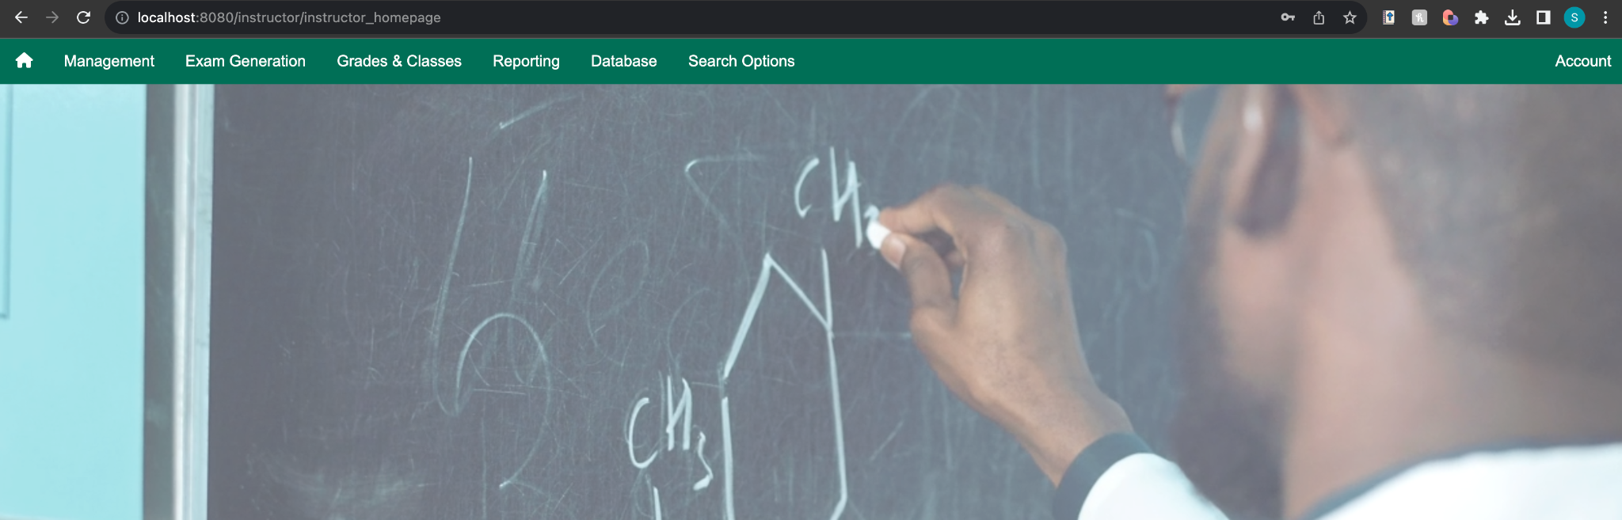

* 1. Management has 5 options under it
  2. Management
     1. Load a Class - This gives the option to the administrator to upload a class and its parameters to the database, and associates the student/teacher with a class.
        1. Choosing file - If you have a file you would like to upload this is where you would upload the file to
        2. Upload - is where you would upload the selected file
     2. Classes & Chapters - This lets the instructor choose between chapters and different examination forms. This is ***under Development***
     3. Exams - Allows the user to pick a class and get redirected to an exam
  3. Exam Generation
     1. A.I. Exam Generation - A full-fledged AI-Exam generator. Simply pick a topic and it will generate an exam for you. See ‘A.I. Exam Generation’ for in-depth user manual information.
     2. Manual Exam Generation - Pick and choose what questions you want to implement based on chapter selection. Edit and manipulate what you want.
  4. Grades and Classes -
     1. This shows the classes that the instructor is associated with, the instructor will then be able to manipulate that class to their curriculum, ***Currently not functioning***
  5. Reporting
     1. Exam information - ***Currently Not Functioning***
     2. IP Address - ***Currently Not Functioning***
  6. Database
     1. View All Students - Takes the instructor to a html page to view/edit/delete students
     2. Add Students - Allows instructor to add a student to the database
     3. Assign Students - Allows instructor to assign a student to their course
     4. Export To Excel - Exports a repository in the database to an excel file
     5. Import with Excel - Redirects to a page where the instructors can import a file via excel
     6. View all Administrators - Allows instructor to view an administrator to the database
  7. Search options
     1. Search - ***Currently not functional***

## **Personal Account Management**

1. Under each account type you are able to edit your personal account information. You need to navigate to the ***Account*** tab in the navigation bar, you will be presented with a drop down and one of options will be ***Account Management*** when you select this tab you will be presented with a page such as this.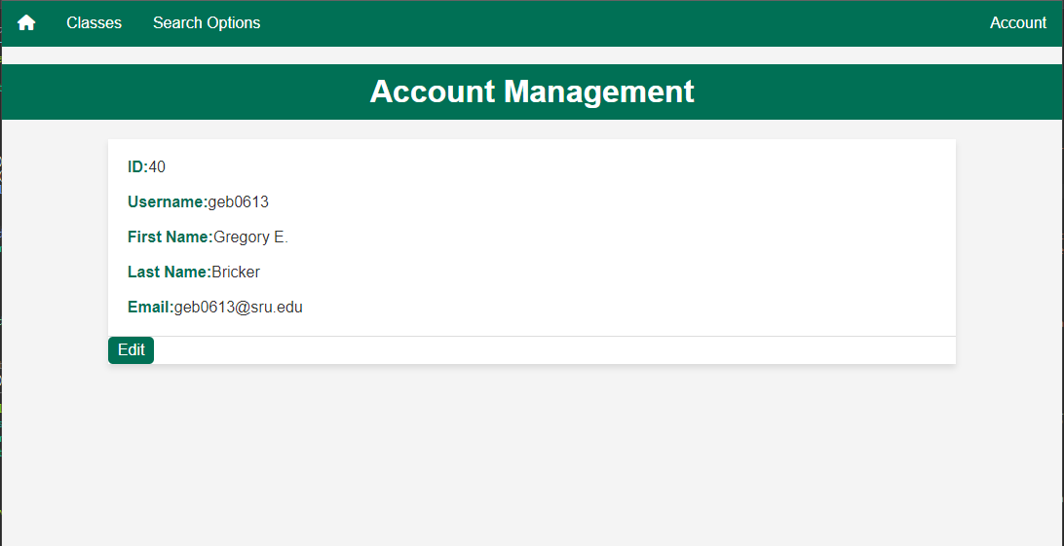
2. If you just need to view your account information you can do that here. If you need to edit your account information you can select the ***Edit*** button, this will present you with a page that looks like this.

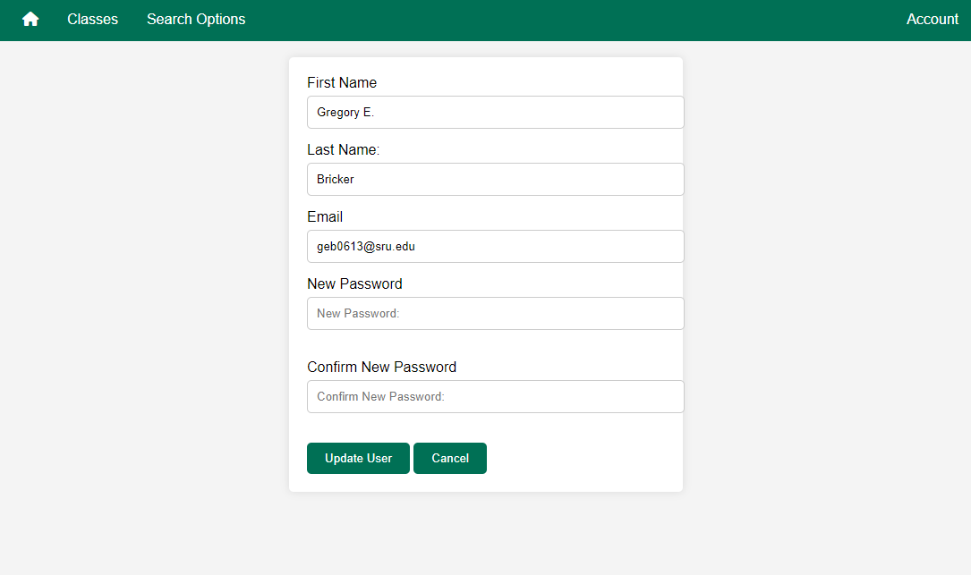

1. On this page you are able to edit each of these fields, one or more, to edit your personal account information. You can save these changes by clicking the ***Update User*** button or click cancel to cancel. 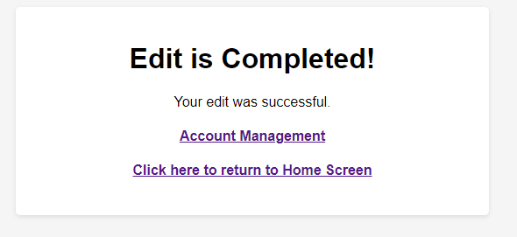
2. If you choose to edit any information and click the ***Update User*** button, you will be presented with a page that looks like this and gives you the option to return to the home screen or to go back to the Account Management page to view the changes that you made.

## **Loading a Class Roster**

* 1. For **testing purposes** there is a file already created and stored in the ***Documents*** folder in our project titled ***class_data.xlsx*** that has the class roster written and formatted for you.
  2. Before loading the data you can login as a schedule manager, the default schedule manager will work fine for this test and create an instructor, or you can just load the ***class_data.xlsx*** as the schedule manager and it will create the instructors login for you. You can do this under the schedule managers ***Management*** tab and clicking on the ***Load a Class*** if done correctly you will be prompted with this screen.

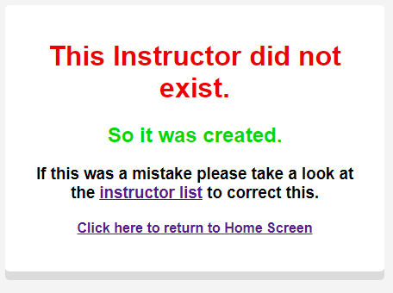

* 1. If you would prefer to create the instructor, for the test data, please create the instructor with the following **highlighted** information, **non highlighted** information will not affect the test.

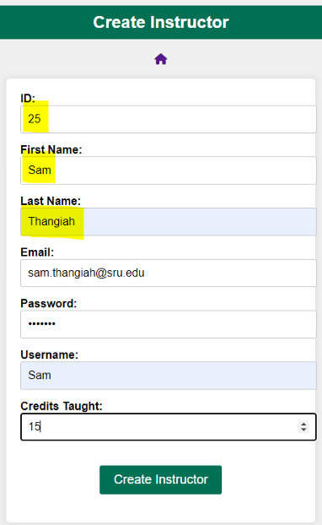

1. First you will need to be logged in as either an instructor (you can use the above mentioned instructor that you created) or schedule manager and use the navigation bar to hover over ***Management*** and select ***Load a Class.***

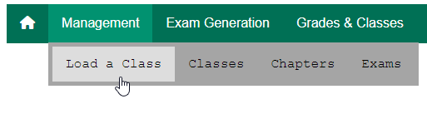

1. You will then need to select ***Choose File*** and use your system file explorer to find your roster loaded with class information.

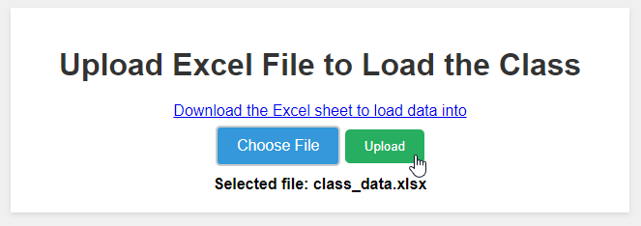

1. Once you select the file you can click upload and you will then be prompted with a success page as long as the roster is formatted correctly.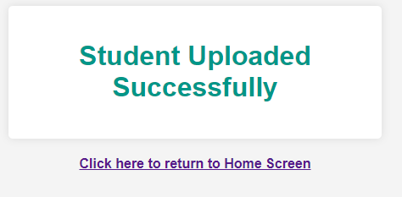
2. You can then navigate to the ***Student List*** page and view the newly added roster of students, you can then login as the student created using their listed ***Username*** and the default password of ***student.***

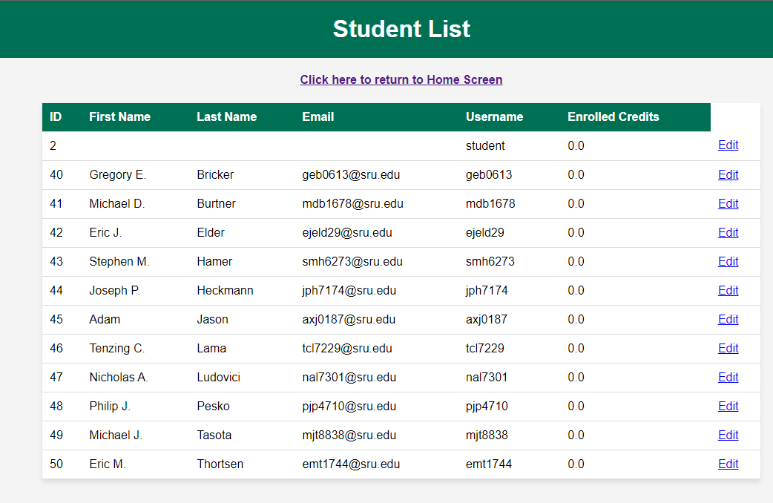

## **Editing a Student**

1. When you need to edit a student, you will need to navigate under the ***Database*** tab and select ***View All Students***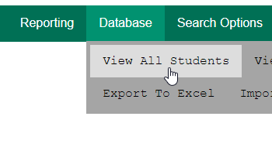
2. You will then be presented with a list of students with an ***Edit*** option beside them.

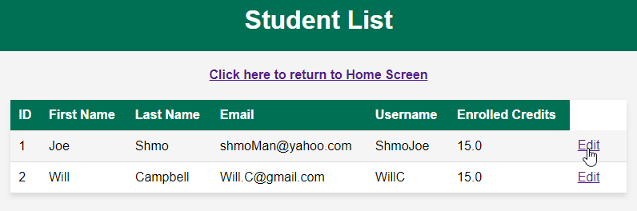

1. When you select the ***Edit*** button, you will be presented with a page where you can edit the students information

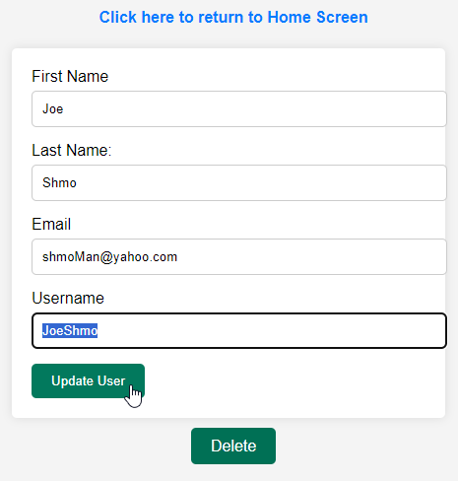

1. The information will be updated in the ***View All Students*** page that you can navigate back to from this page.

 